

**ELECTRICITY BILL MANAGEMENT SYSTEM**

**Course Name :** INTRODUCTION TO DATABASE

**Semester :** SPRING (2017-2018)

**Sec :** F

**Department :** CSE, SE & CSSE

**Group Member :** 4

**Instructor :** JUENA AHMED NOSHIN

**Group Members :**

|  |  |  |  |
| --- | --- | --- | --- |
| Sl. | Name. | Id. | Dept. |
| 01 | Bhuyan, Al-Noor Fahim | 17-33831-1 | CSE |
| 02 | Roy, Tushar | 17-33880-1 | CSE |
| 03 | Hasan, Khandaker Rafat | 17-33866-1 | SE |
| 04 | Tamanna, Sadika | 17-33210-1 | CSSE |

**Due Date :** 19/04/2018

**TABLE OF CONTENTS**

**S.NO TITLE**

01 INTRODUCTIONS

02 SCENARIO DESCRIPTIONS

03 ENTITY-RELATIONSHIP DIAGRAMS

04 NORMALIZATIONS

05 TABLE CREATIONS

06 ALTER WITH CONSTRAINTS

07 DATA INSERTIONS

08 QUERIES WRITING

09 CONCLUSIONS

**01. INTRODUCTIONS:**

A database management system is system software for creating and managing database. The DBMS provide user and programmers with a systematic way to create, retrieve, update and manage data.

In this project, an Electricity Bill Management System is creating by the concept of DBMS. So, the main purpose of this project is to know about the basic concept of database management system.

**02. SCENARIO DESCRIPTIONS:**

An electricity supply company has many branches. Each branch has its own name, address, email id and phone number. Each branch is runes by employees. Employees are recognized by a unique id. Employee details containing name, phone number, address is also stored. Each branch is managed by a manager. A manager is identified by a manager id. Also, the name, address, phone number of each manager is stored. Company supply electricity. Also, manager controls the electricity. Electricity is used by consumers. Consumers are recognized by consumer id. Also, the name, address, phone of the consumers is stored. Each consumer has its own consumption record. Each consumption record consists of quantity and amount. Each consumption record is counted by a meter. Bill consumption record varies on rate. Each meter is identified by a meter number. Also, the meter owner name is stored in the system. Electricity bill is calculated by the employees of electricity supply company monthly from the meters. Consumers go to electricity supply office to pay the bill. Employees of the company collect the bills from the consumers. The bill payment record is also stored by the employees. Each payment record consists of user id, user name, amount, paid, non-paid.

**03. E-R DIAGRAMS:**

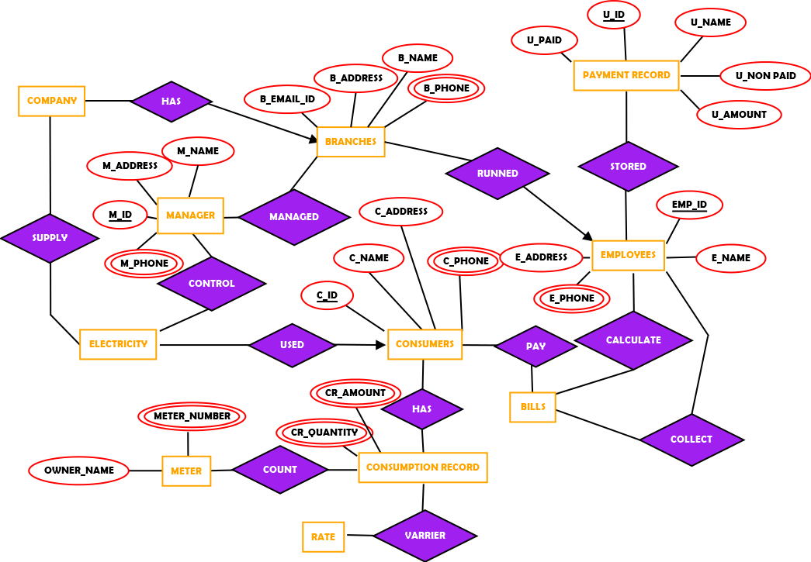

**04. NORMALZATION:**



**UNF:**

runned (b_email_id, b_name, b_address, b_phone, emp_id, e_name, e_address, e_phone)

**1NF:**

b_phone & e_phone are multivalued attributes.

(b_email_id, b_name, b_address, b_phone, emp_id, e_name, e_address, e_phone)

**2NF:**

(b_email_id, b_name, b_address, b_phone)

(emp_id, e_name, e_address, e_phone)

**3NF:**

(b_email_id, b_name)

(b_address, b_phone)

(emp_id, e_name)

(e_address, e_phone)

**BCNF:**

already in BCNF

(b_email_id, b_name)

(b_address, b_phone)

(emp_id, e_name)

(e_address, e_phone)

**4NF:**

already in 4NF

(b_email_id, b_name)

(b_address, b_phone)

(emp_id, e_name)

(e_address, e_phone)

**TABLE CREATING (RUNNED):**

(1) (b_email_id, b_name, emp_id)

(2) (b_address, b_phone, emp_id)

(3) (emp_id, e_name)

(4) (e_address, e_phone, emp_id)



**UNF:**

managed (b_email_id, b_name, b_address, b_phone, m_id, m_name, m_address, m_phone)

**1NF:**

b_phone & m_phone are multivalued attributes

(b_email_id, b_name, b_address, b_phone, m_id, m_name, m_address, m_phone)

**2NF:**

(b_email_id, b_name, b_address, b_phone)

(m_id, m_name, m_address, m_phone)

**3NF:**

(b_email_id, b_name)

(b_address, b_phone)

(m_id, m_name)

(m_address, m_phone)

**BCNF:**

already in BCNF

(b_email_id, b_name)

(b_address, b_phone)

(m_id, m_name)

(m_address, m_phone)

**4NF:**

already in 4NF

(b_email_id, b_name)

(b_address, b_phone)

(m_id, m_name)

(m_address, m_phone)

**TABLE CREATING (MANAGED):**

(1) (b_email_id, b_name, m_id)

(2) (b_address, b_phone, m_id)

(3) (m_id, m_name)

(4) (m_address, m_phone, m_id)



**UNF:**

stored (emp_id, e_name, e_address, e_phone, u_id, u_name, u_amount, u_paid, u_unpaid)

**1NF:**

e_phone is a multivalued attribute

(emp_id, e_name, e_address, e_phone, u_id, u_name, u_amount, u_paid, u_unpaid)

**2NF:**

(emp_id, e_name, e_address, e_phone)

(u_id, u_name, u_amount, u_paid, u_unpaid)

**3NF:**

(emp_id, e_name)

(e_address, e_phone)

(u_id, u_name)

(u_amount, u_paid, u_unpaid)

**BCNF:**

already in BCNF

(emp_id, e_name)

(e_address, e_phone)

(u_id, u_name)

(u_amount, u_paid, u_unpaid)

**4NF:**

already in 4NF

(emp_id, e_name)

(e_address, e_phone)

(u_id, u_name)

(u_amount, u_paid, u_unpaid)

**TABLE CREATING (STORED):**

(1) (emp_id, e_name, u_id)

(2) (e_address, e_phone, u_id)

(3) (u_id, u_name, emp_id)

(4) (u_amount, u_paid, u_unpaid, u_id)



**UNF:**

has (c_id, c_name, c_address, c_phone, cr_amount, cr_quantity)

**1NF:**

c_phone, cr_amount & cr_quantity are multivalued attributes

(c_id, c_name, c_address, c_phone, cr_amount, cr_quantity)

**2NF:**

(c_id, c_name, c_address, c_phone)

(cr_amount, cr_quantity)

**3NF:**

(c_id, c_name)

(c_address, c_phone)

(cr_amount, cr_quantity)

**BCNF:**

already in BCNF

(c_id, c_name)

(c_address, c_phone)

(cr_amount, cr_quantity)

**4NF:**

already in 4NF

(c_id, c_name)

(c_address, c_phone)

(cr_amount)

(cr_quantity)

**TABLE CREATING (HAS):**

(1) (c_id, c_name)

(2) (c_address, c_phone, c_id)

(3) (cr_amount, cr_id, c_id)

(4) (cr_quantity, cr_id, c_id)



**UNF:**

count (owner_name, meter_number, cr_amount, cr_quantity)

**1NF:**

meter_number, cr_amount, cr_quantity are multivalued attributes

(owner_name, meter_number, cr_amount, cr_quantity)

**2NF:**

(owner_name, meter_number)

(cr_amount, cr_quantity)

**3NF:**

(owner_name, meter_number)

(cr_amount, cr_quantity)

**BCNF:**

already in BCNF

(owner_name, meter_number)

(cr_amount, cr_quantity)

**4NF:**

already in 4NF

(owner_name, meter_number)

(cr_amount)

(cr_quantity)

**TABLE CREATING (COUNT):**

(1) (owner_name, meter_number, cr_id)

(2) (cr_amount, cr_id)

(3) (cr_quantity, cr_id)

**05. TABLE CREATIONS:**

(1) (b_email_id, b_name, b_address, b_phone, emp_id, m_id)

Table name - **Branches**

(2) (emp_id, e_name, e_address, e_phone, u_id)

Table name - **Employees**

(3) (m_id, m_name, m_address, m_phone)

Table name - **Manager**

(4) (u_id, u_name, u_amount, u_paid, u_unpaid)

Table name - **Payment_Record**

(5) (c_id, c_name, c_address, c_phone)

Table name - **Consumers**

(6) (cr_amount, cr_id, cr_quantity, c_id)

Table name - **Consumption_Record**

(7) (owner_name, meter_number, cr_id)

Table name - **Meter**

Screenshot of creating table using describe command:

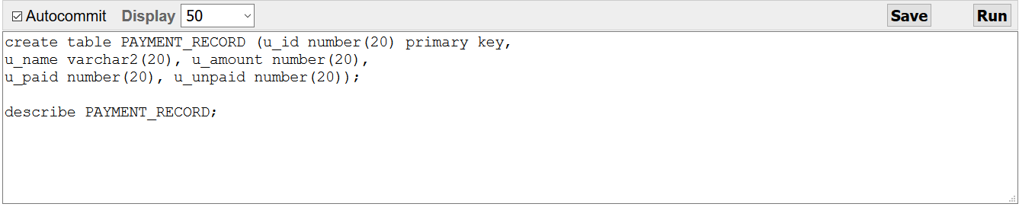

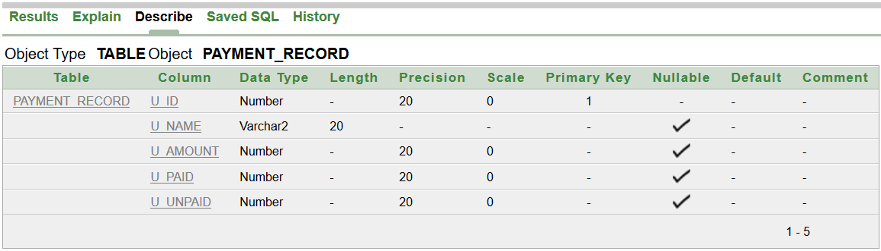

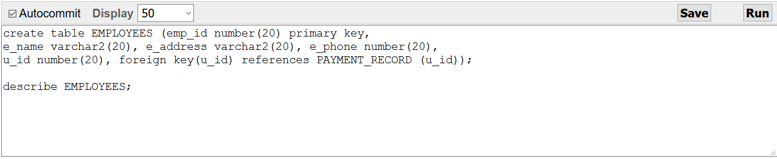

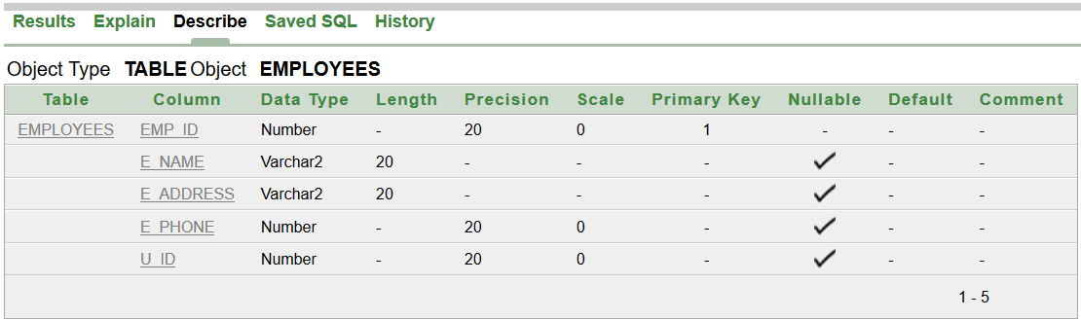

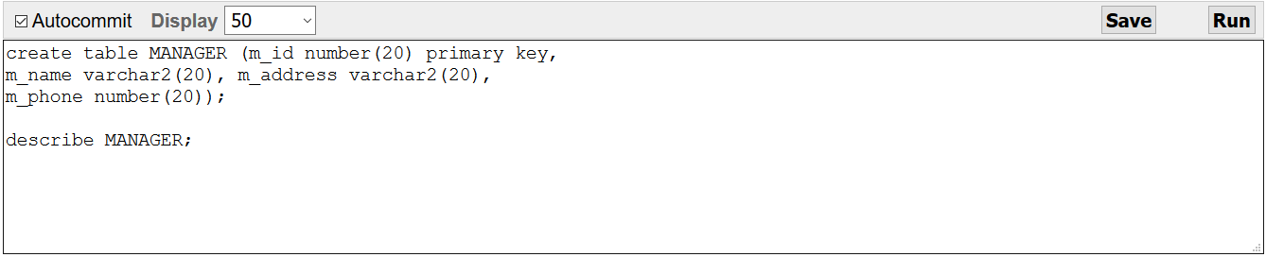

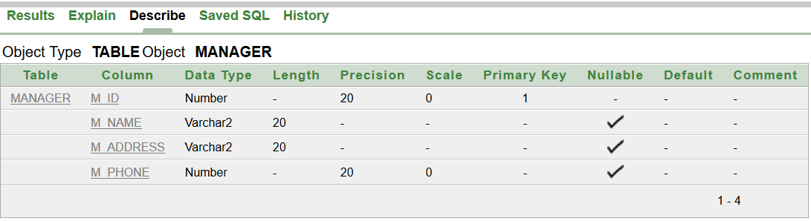

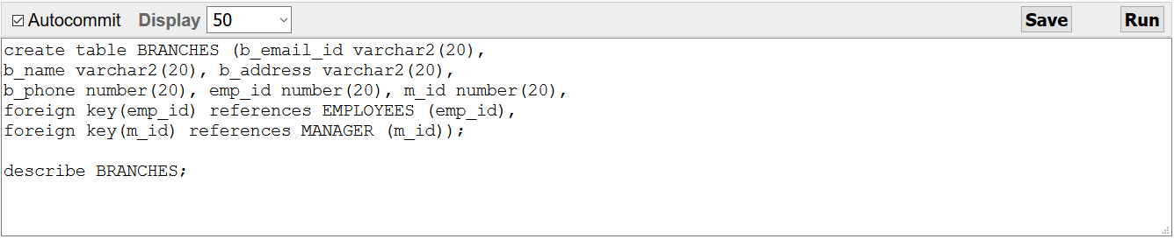

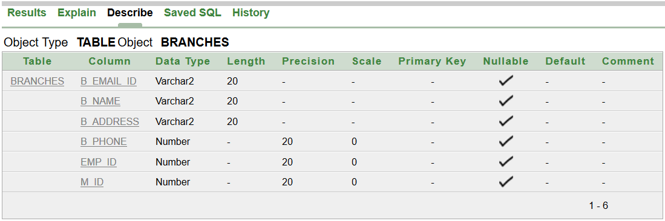

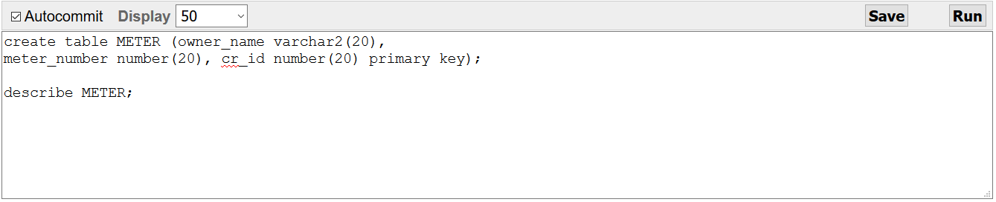

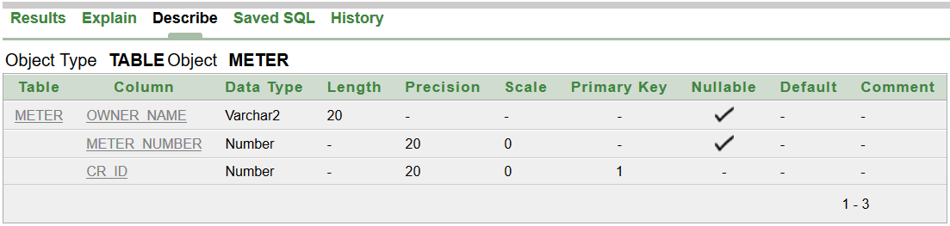

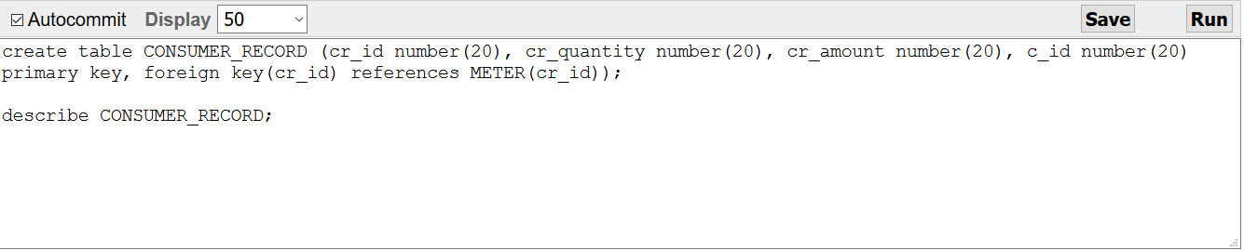

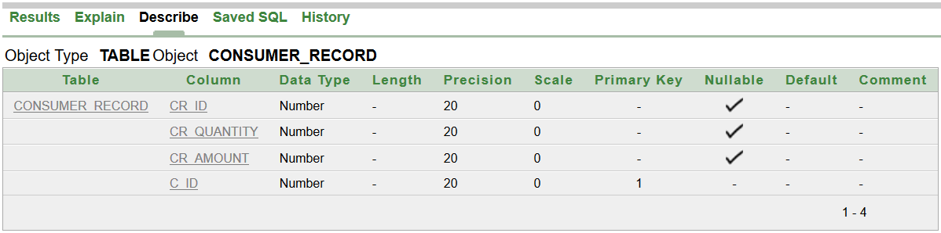

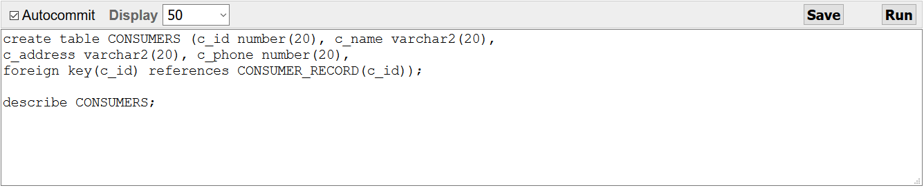

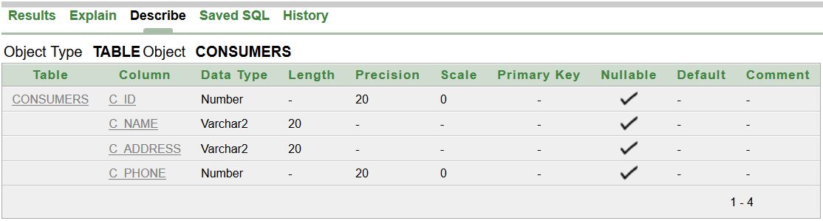

**06 ALTER WITH CONSTRAINTS:**

alter table EMPLOYEES add constraint u_id foreign key(u_id) references PAYMENT_RECORD(u_id);

alter table BRANCHES add constraint emp_id foreign key(emp_id) references EMPLOYEES(emp_id);

alter table BRANCHES add constraint m_id foreign key(m_id) references MANAGER(m_id);

alter table CONSUMER_RECORD add constraint cr_id foreign key(cr_id) references METER(cr_id);

alter table CONSUMERS add constraint c_id foreign key(c_id) references CONSUMER_RECORD(c_id);

**07 DATA INSERTIONS:**

Table – PAYMENT_RECORD

insert into PAYMENT_RECORD values (110,'Rahim',1500,1500,0);

insert into PAYMENT_RECORD values (120,'Sabbir',1800,1200,600);

insert into PAYMENT_RECORD values (130,'Smith',1000,950,50);

insert into PAYMENT_RECORD values (140,'Tylor',5000,3200,1800);

insert into PAYMENT_RECORD values (150,'Ruba',1400,1400,0);

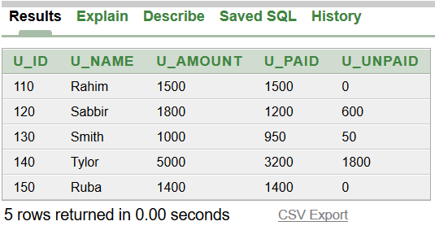

Table – EMPLOYEES

insert into EMPLOYEES values (1010,'John','Dhaka',62345,110);

insert into EMPLOYEES values (1020,'Rana','Chittagong',82945,120);

insert into EMPLOYEES values (1030,'Rasel','Khulna',81046,130);

insert into EMPLOYEES values (1040,'Andrew','Rajshahi',10086,140);

insert into EMPLOYEES values (1050,'Jerin','Sylhet',90153,150);

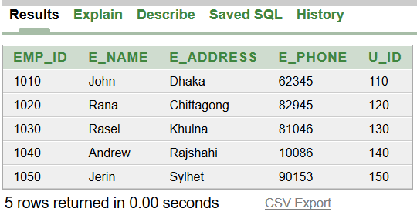

Table – MANAGER

insert into MANAGER values (91101,'Sohel','Dhaka',90222);

insert into MANAGER values (91201,'Roman','Chittagong',90333);

insert into MANAGER values (91301,'Roy','Khulna',90444);

insert into MANAGER values (91401,'Hasan','Rajshahi',90555);

insert into MANAGER values (91501,'Watson','Sylhet',90666);

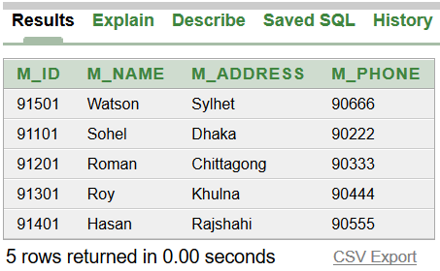

Table – BRANCHES

insert into BRANCHES values ('dhaka1@gmail.com','Dhaka Branch','Dhaka',02888, 1010, 91101);

insert into BRANCHES values ('chittagong@gmail.com','Chittagong Branch','Chittagong',03888, 1020, 91201);

insert into BRANCHES values ('khulna1@gmail.com','Khulna Branch','Khulna',04888, 1030, 91301);

insert into BRANCHES values ('rajshahi1@gmail.com','Rajshahi Branch','Rajshahi',05888, 1040, 91401);

insert into BRANCHES values ('sylhet1@gmail.com','Sylhet Branch','Rajshahi',06888, 1050, 91501);

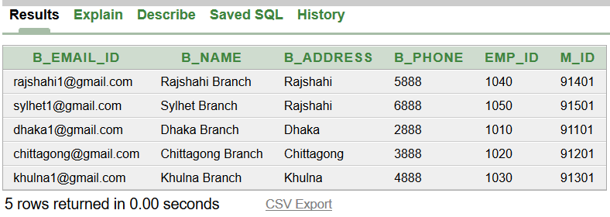

Table – METER

insert into METER values ('Rahim',5552431,998324);

insert into METER values ('Sabbir',6662431,992834);

insert into METER values ('Smith',7772431,994864);

insert into METER values ('Tylor',8882431,996664);

insert into METER values ('Ruba',9992431,998724);

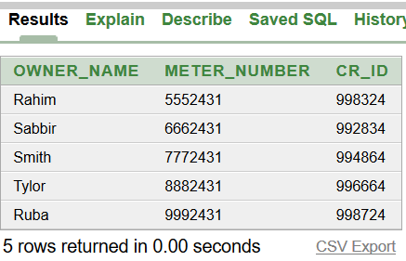

Table – CONSUMER_RECORD

insert into CONSUMER_RECORD values ('998324',3,15000,5882);

insert into CONSUMER_RECORD values ('992834',5,18000,5782);

insert into CONSUMER_RECORD values ('994864',2,10000,5682);

insert into CONSUMER_RECORD values ('996664',8,50000,5582);

insert into CONSUMER_RECORD values ('998724',3,14000,5482);

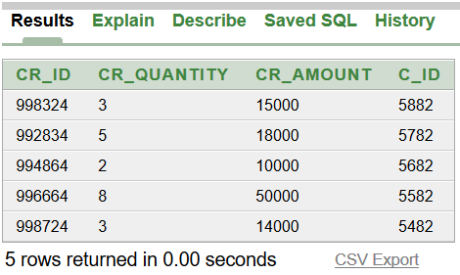

Table – CONSUMERS

insert into CONSUMERS values (5882,'Rahim','Dhaka',13546);

insert into CONSUMERS values (5782,'Sabbir','Chittagong',13646);

insert into CONSUMERS values (5682,'Smith','Khulna',13886);

insert into CONSUMERS values (5582,'Tylor','Rajshahi',13204);

insert into CONSUMERS values (5482,'Ruba','Sylhet',13199);

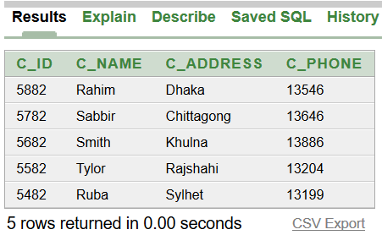

**08 QUERIES WRITING:**

3 – Single Row Function:

Q: Display the user name, user amount, user paid and user unpaid for user Tylor.

A: SELECT u_name, u_amount, u_paid, u_unpaid from PAYMENT_RECORD WHERE u_name = 'Tylor';

Q: Display the employer name, address and phone number whose id is 1030.

A: SELECT e_name, e_address, e_phone from EMPLOYEES WHERE emp_id = 1030;

Q: Display the consumers name, id number and address whose phone number is 13199.

A: SELECT c_id, c_name, c_address from CONSUMERS WHERE c_phone = 13199;

3 – Group Function:

Q: Display the average, maximum, minimum and total amount from Payment Records.

A: SELECT AVG(u_amount), MAX(u_amount), MIN(u_amount), SUM(u_amount) from PAYMENT_RECORD;

Q: Display the user id numers whome had paid more than 1300 from Payment Records.

A: SELECT u_id, max(u_paid) from PAYMENT_RECORD group by u_id having max(u_paid)>1300;

Q: Display the user id numers whome had paid less than 1200 from Payment Records.

A: SELECT u_id, max(u_paid) from PAYMENT_RECORD group by u_id having max(u_paid)<1450;

2 – Subquery:

Q: Display the cr_id, cr_quantity and c_id where cr_amount is more than 14000.

A: SELECT cr_id, cr_quantity, cr_amount, c_id from CONSUMER_RECORD WHERE cr_amount >

(SELECT cr_amount from CONSUMER_RECORD

WHERE c_id=5482);

Q: Display the cr_id, cr_quantity and c_id where cr_amount is less than 1800.

A: SELECT cr_id, cr_quantity, cr_amount, c_id from CONSUMER_RECORD WHERE cr_amount <

(SELECT cr_amount from CONSUMER_RECORD

WHERE c_id=5782);

2 – Joining:

Q: Display the Branches name, address, phone number and Employees name, address, phone number Equijoins with Employees Id.

A: SELECT b.b_name, b.b_address, b.b_phone, b.emp_id, e.emp_id, e.e_name, e.e_address, e.e_phone from BRANCHES b, EMPLOYEES e WHERE b.emp_id = e.emp_id;

Q: Display the Consumers name, address, phone number and Consumers amount, quantity Equijoins with Consumers Id.

A: SELECT c.c_name, c.c_address, c.c_phone, c.c_id, cr.c_id, cr.cr_amount, cr.cr_quantity from CONSUMERS c, CONSUMER_RECORD cr WHERE c.c_id = cr.c_id;

**09 CONCLUSIONS:**

After finishing the project, the basic concept of database management system is known to us. Now each of the group member will try to make any management system in future.